Code Smell 3: Dead Code

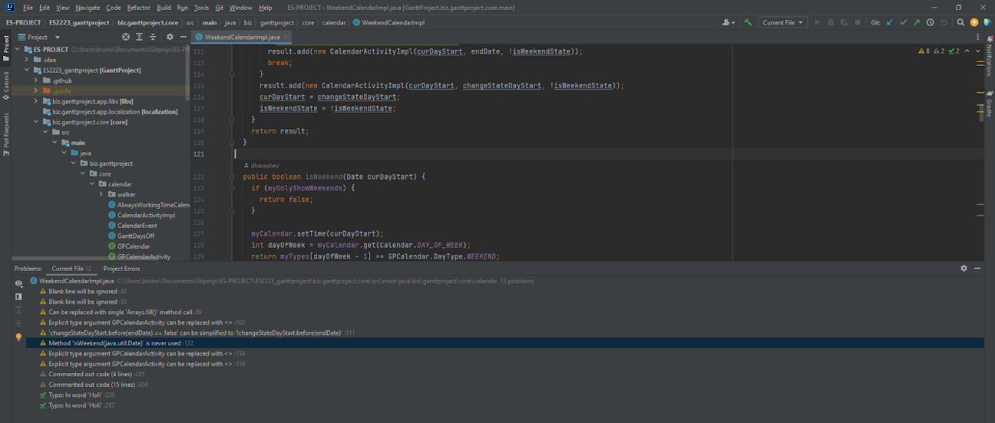

**Location of the code smell from repository root:**

biz.ganttproject.core/src/main/java/biz/ganttproject/core/calendar/WeekendCalendarImpl.java , line number 122.

**Explanation:**

The method isWeekend(Date curDayStart) is never used, also known as dead code.

**Refactoring proposal:**

This method should be deleted.